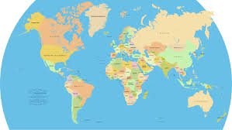
POSTER PROJECT

- Research your country and create a scrapbook poster filled with items you may collect if you could travel there.

2) Create souvenir objects (like ticket stubs, postcards, brochures, recipes of popular foods, maps, and coins) and attach them to your scrapbook poster. Three dimensional objects can be placed in a resealable plastic bag and taped to the poster. Write a sentence next to each object that explains its significance or why it is important to your country. (You may do this on index cards and attach them to your poster)

3) You may draw photographs of sights or places of interest in your country. You may also copy and print photographs from the internet if you’d like. You may include holidays, sports, pictures of children, or anything that represents your country.

4) You must have at least 8 objects on your poster! Each object must have a sentence explaining why the object is important to your country.

5) Make sure your scrapbook poster displays the name of your country in big, bold letters.

6) This project is due on April 23rd.

_______________________ is researching _______________________

Our family is aware that __________________ should be working on his/her poster over the next 2 weeks.
________________________________________________________________
Parent signature

